# WEB PROGRAMIRANJE 2

<https://theikevinhart.netlify.com/>

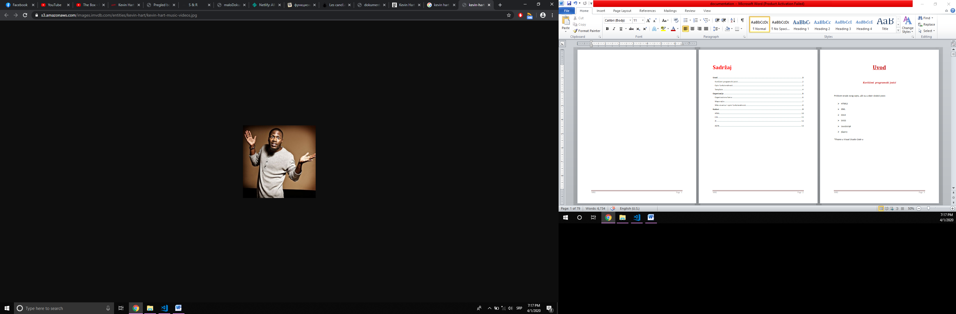

Sadržaj

**Uvod3**

Korišćeni programski jezici2

Opis funkcionalnosti3

Template4

**Organizacija5**

Organizaciona šema6

Mapa sajta7

Slike stranica I opisi funkcionalnosti8

**Kodovi9**

HTML10

CSS11

JS12

JSON13

# Uvod

## *Korišćeni programski jezici*

Prilikom izrade ovog sajta, ušli su u obzir sledeći jezici:

* HTML5
* XML
* CSS3
* SASS
* JavaScript
* jQuery

*\*Pisano u Visual Studio Code-u­*

## *Opis funkcionalnosti*

U zavisnosti koja je stranica učitana, sledeće sposobnosti sajta se izvršavaju kroz:

* **JSON i Ajax**- koji dovode sadržaj, poput dešavanja, vesti i njihove kategorije, dodatan opis protagoniste itd, na svoje mesto
* **CSS**- koji im pomaže se prethodno srede i stilizuju, te spremni za svaki ekran, izađu na scenu
* **JS**- koji kao glavni mašinovođa obavlja sve funkcionalnosti i uspeva da ispiše sitnije elemente sajta na samom početku (meni, društvene mreže, liste kategorija za filtriranje itd), krupnije uz pomoć prethodno navedenih JSON-a i Ajaxa, omogući opcije poput sortiranja i filtriranja za vesti, proveri da li je korisnik negde zabrljao pri unošenju podataka u formi, i ako nije, da ga uspešno dočeka (bez izuvanja) u sajt koji dobija novu sposobnost (pošto je ime korisnika prethodno sačuvao u Local Storage-u), a to je da dozvoljava korisniku, s obzirom na to da je ulogovan, da pošalje poruku, koju takođe pre toga čina i pregleda
* **jQuery**- uvek na vrhuncu zadatka sa svojim animatorskim sposobnostima, daje korisniku prijatan efekat prilikom kliktanja na meni ili isključivanja modala

## *Tempate*

*\*S obzirom na to da se nije koristio nijedan template, ručno se pisao kod.*

### INDEX.HTML

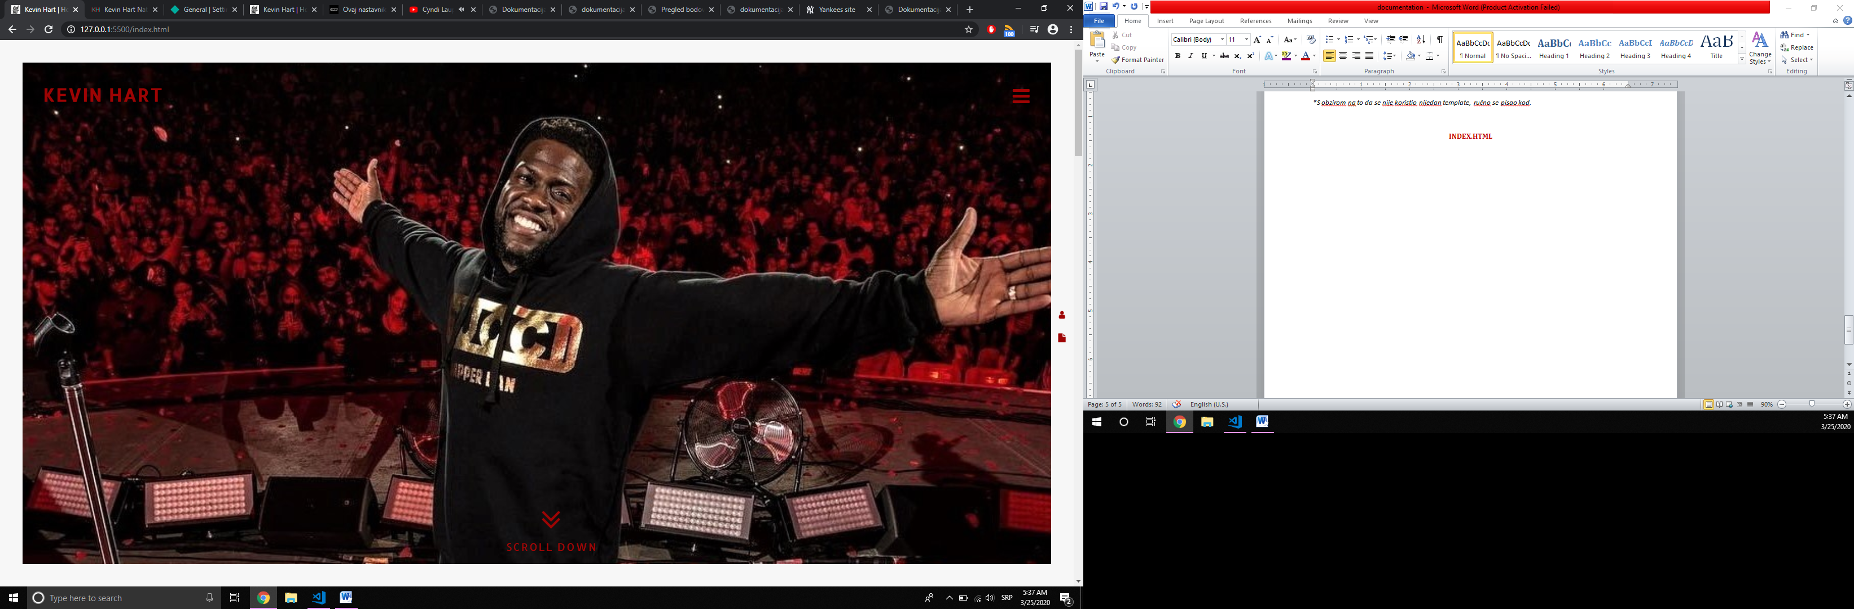

**#slajder**

**Scroll na sadržaj**

**#logo**

**#meni**

**documentation**

**#autor (modal)**

*\*Okolo su 4 ivice, a ceo sadržaj je unutar #omotac-a*

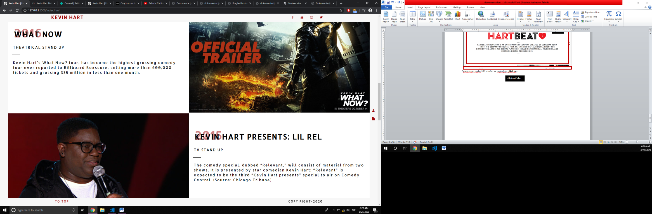*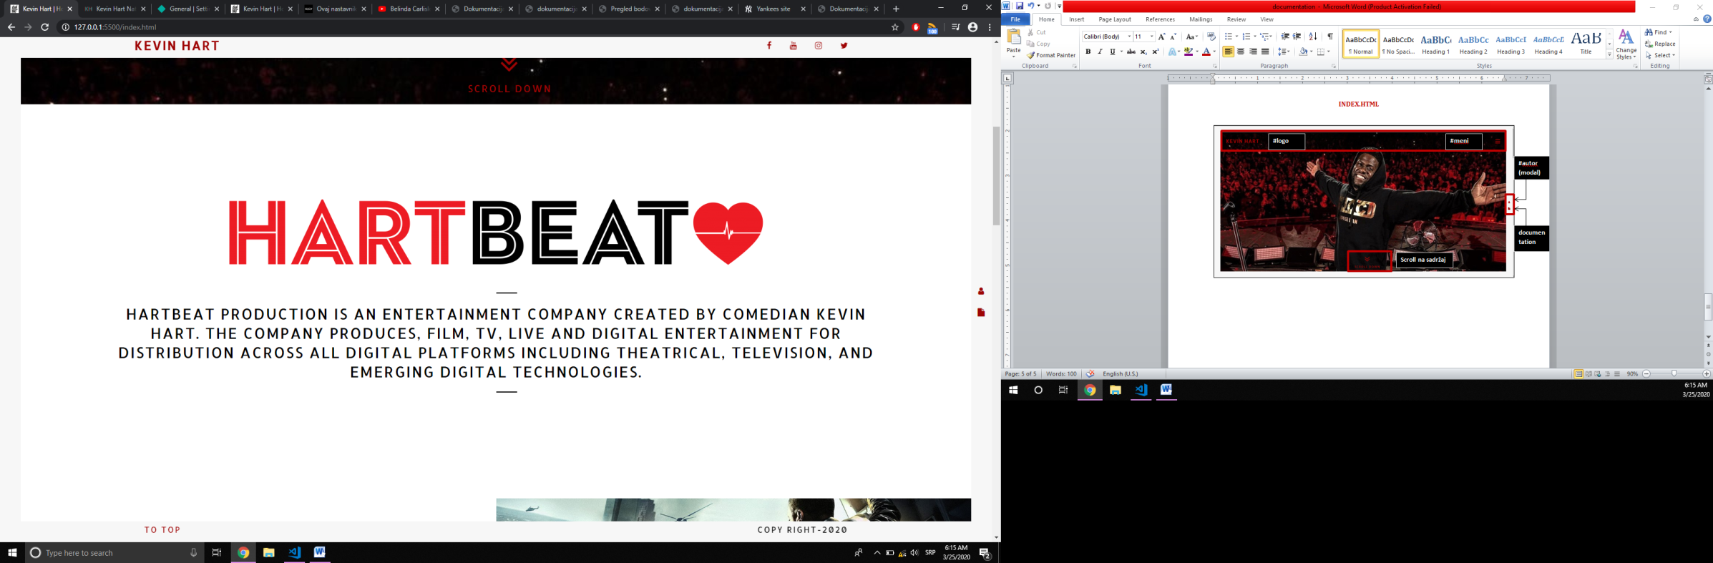*prelaskom preko 300 scroll-a se pojavljuju* ***.fiksiran…***

**#dobrodoslica**

**#izlogovanje**

**.fleksuj**

**.fleksuj**

**.desavanje**

**#desavanja**

**#uvod**

**#sadrzaj**

**.fiksiranMeni**

**.fiksiranFuter**

***\*\*#dobrodoslica-#izlogovanje*** *tek kada je korisnik popunio formu I ulogovao se*

*\*Prikazuje se tek kad se klikne na fa-bars, tj. meni **S dodatnom opcijom ta izlogovanje*

**LOGOUT**

**#crnMeni**

### BLOG.HTML

### 

**za filtriranje**

**#naslov**

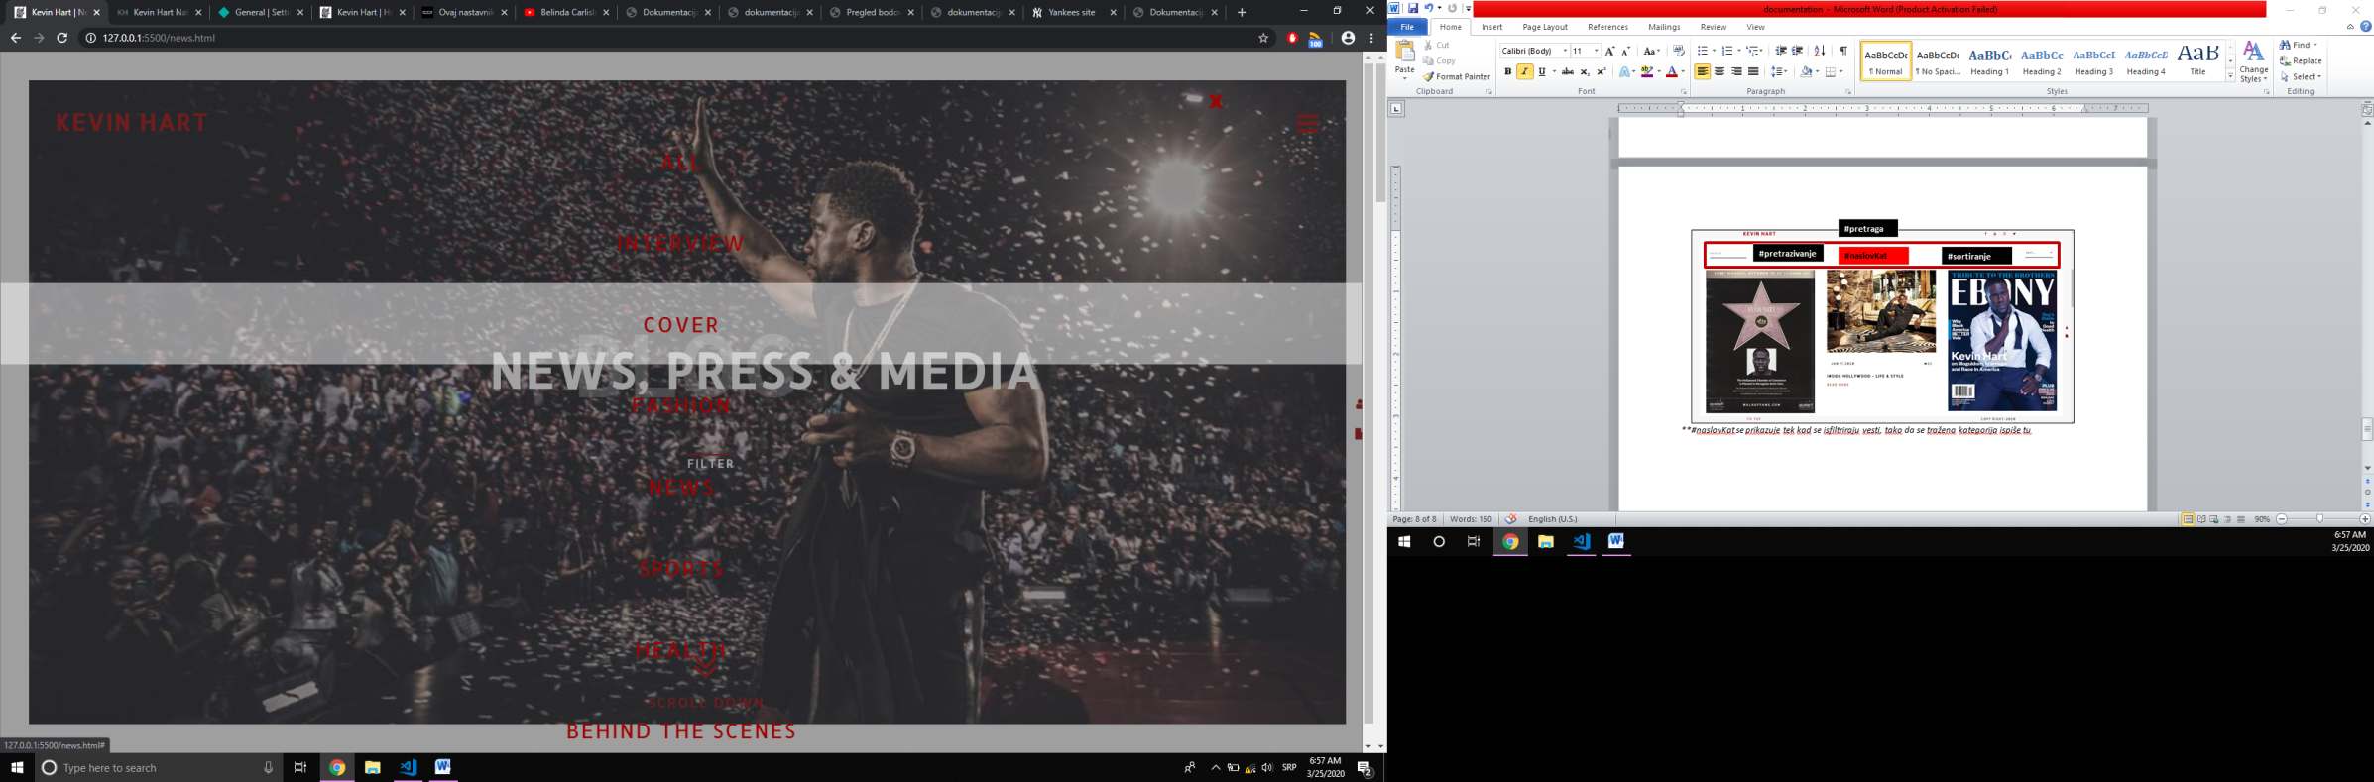*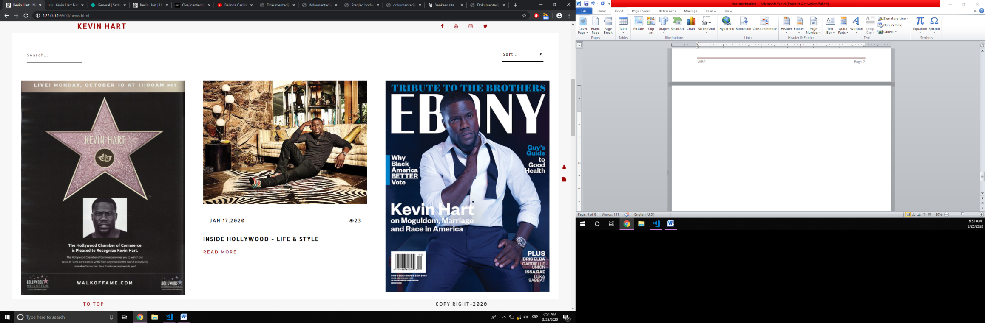**#****naslovKat*** *se prikazuje tek kad se isfiltriraju vesti, tako da se tražena kategorija ispiše tu*

**#listaFiltera**

**#listaKategorija**

**#naslovKat**

**#sortiranje**

**#pretrazivanje**

**#pretraga**

*\*\*Klikom na opciju* ***FILTER*** *se prikazuje modal u vidu liste s nazivima kategorija vesti*

### BLOG.HTML

**.fleksuj**

**.fleksuj**

**.deO**

### 

**#kontaktiranje**

**.deO3**

**.deO**

**.deO**

**.fleksuj**

**.fleksuj**

**.fleksuj**

**.fleksuj**

**.fleksuj**

**.fleksuj**

**.fleksuj**

**.fleksuj**

**.fleksuj**

### 

**#autor**

**#modal**

**.fleksuj**

# Organizacija

## *Organizaciona šema*

### 

NEWS.HTML

ABOUT.HTML

CONTACT.HTML

INDEX.HTML

## *Mapa sajta*

<?xml version="1.0" encoding="UTF-8"?>

<urlset xmlns="http://www.sitemaps.org/schemas/sitemap/0.9">

<url>

<loc>https://theikevhart.netlify.com/index.html</loc>

<lastmod>2020-02-25</lastmod>

<changefreq>yearly</changefreq>

<priority>1.00</priority>

</url>

<url>

<loc>https://theikevhart.netlify.com/news.html</loc>

<lastmod>2020-02-25</lastmod>

<changefreq>yearly</changefreq>

<priority>0.90</priority>

</url>

<url>

<loc>https://theikevhart.netlify.com/about.html</loc>

<lastmod>2020-02-25</lastmod>

<changefreq>yearly</changefreq>

<priority>0.50</priority>

</url>

<url>

<loc>https://theikevhart.netlify.com/contact.html</loc>

<lastmod>2020-02-25</lastmod>

<changefreq>yearly</changefreq>

<priority>0.70</priority>

</url>

<url>

</urlset>

## *Slika stranica I opisi funkcionalnosti*

### INDEX.HTML

### 

Topli doček slikom u slajderu, zatim hamburger koji, u slučaju da se klikne na njega, spušta crn prozorčić I otvara meni u kojem su linkovi koji vode ka drugim stranicama ovoga sajta, *scroll down* strelica koja malkice spušta sajt ka svom centralnom sadržaju i s desne strane modal o meni I link ka ovome,su na prvi pogled vidljive sposobnosti sajta prikazani na prethodnoj slici.

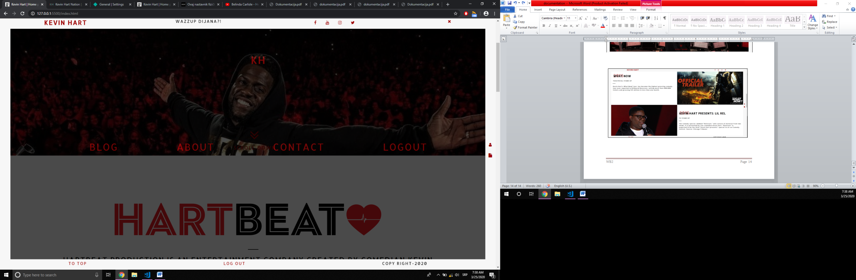Dva bloka ispunjena sadržajem iz jednog JSON(events.json) fajla. S obzirom na to da se skrolovalo ka dole(I prešla određena granica), sadržaj u ivicama se popunio mini podacima poput Logo-a, društvenih mreža, TO TOP(koji klikom vodi ka vrhu stranice) I copyrights. Ukoliko je ulogovan, u sredini će biti I dobrodošlica, kao I opcija da se izloguje(isto tako I u crnom meniju).Takođe, se I ***X*** ikonica premešta,zajedno sa menijem. Lepše sročeno na narednoj slici:

Ukoliko je korisnik odlučio da vidi šta se dešava u životu protagoniste, prikazuje se ova stranica. Klikom na opciju ***filter*** se otvara beličast modal, koji sadrži listu dovučenu iz JSON-a(categories.json) I klikom na pojedinačni, filtrira dole naredni sadržaj u skladu sa kategorijom, koju takođe I ispisuje kao podnaslov.

Ovde se nalaze sve vesti učitane iz JSON-a(news.json) koje mogu da se sortiraju opadajuće I rastuće po datumu kreiranja, kao I opadajuće po gledanosti. Dodatna mogućnost filtriranja se realizuje kroz pretragu I ukucavanjem slova/reči u nju.

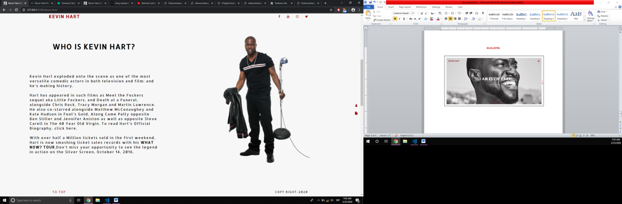**

Čist kratak opis I istorija direkt pisana u HTML-u kraj koje stoji slika dotičnog.

Ceo sadržaj presut Iz JSON-a(boys.json) u ovom delu, a u narednom iz (roles.json).

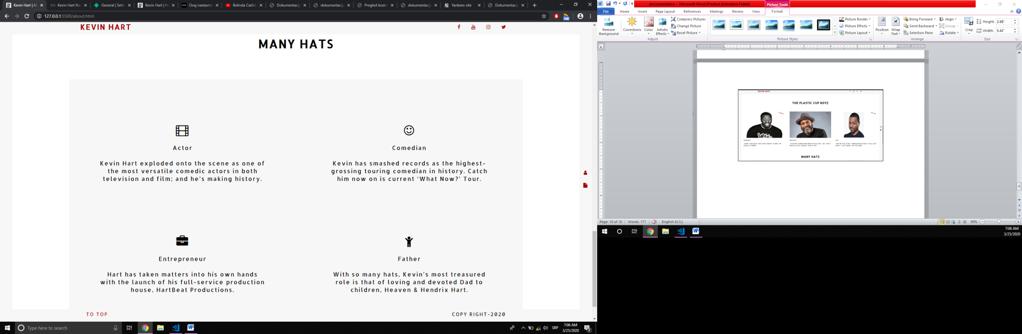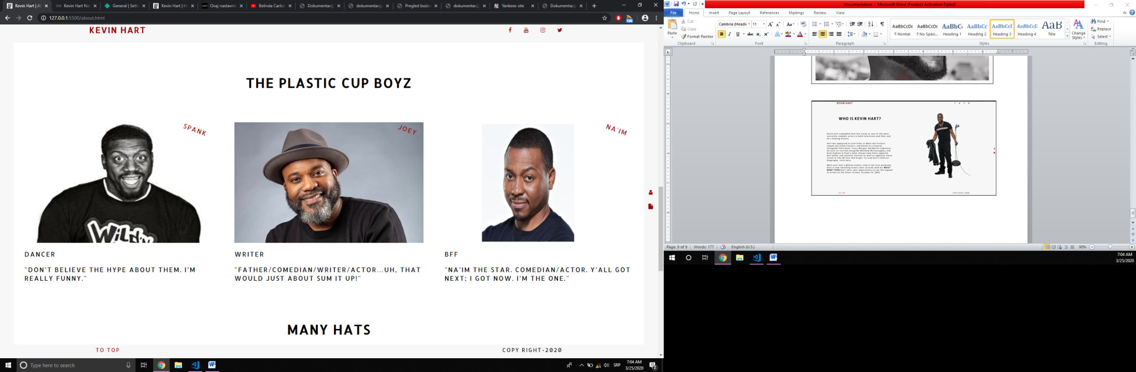

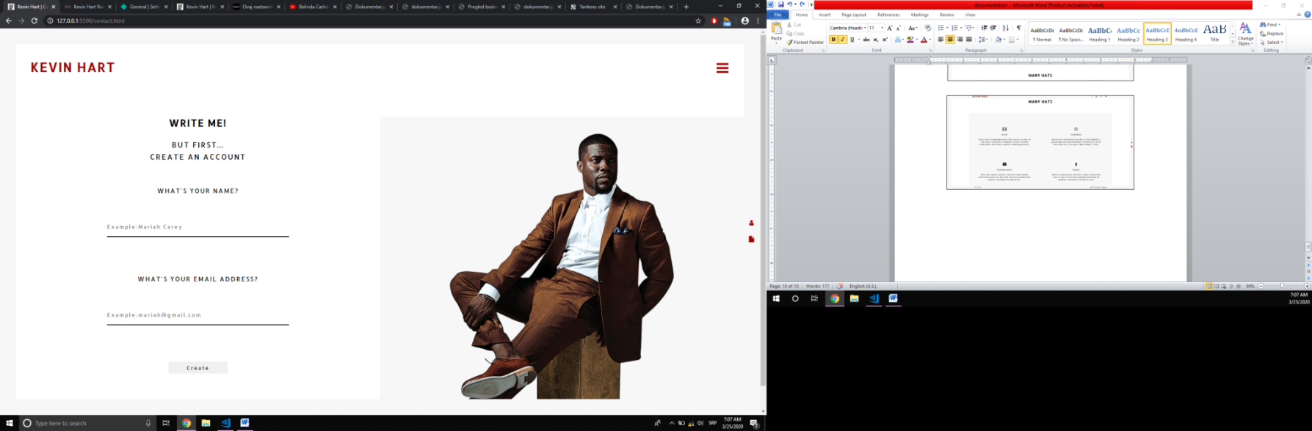

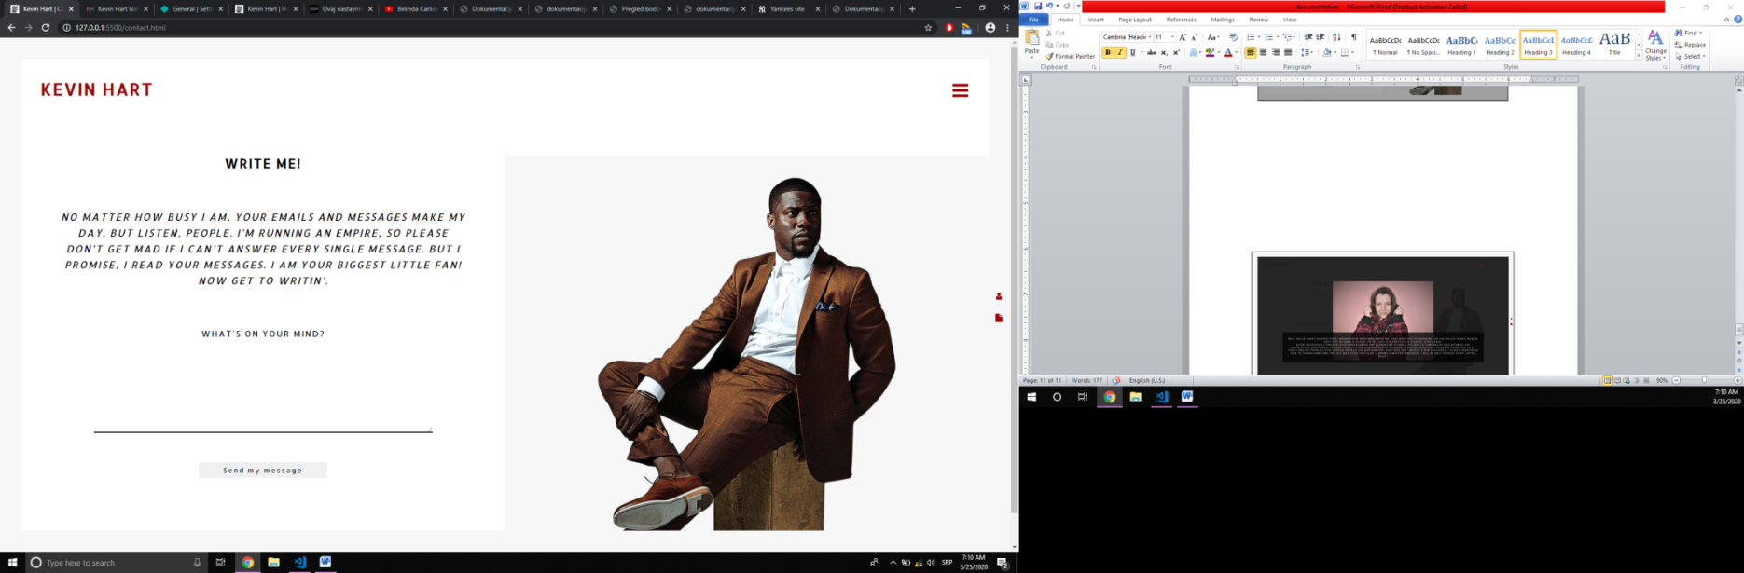Provera unetih podataka,i ukoliko su korektni, upisuje ***Name*** u Local Storage, I izbacuje ***Welcome*** modal

*\*\*Proveravaju se obe forme regularnim izrazima I boje se polja nakon klika na Create/Send dugme!!!*

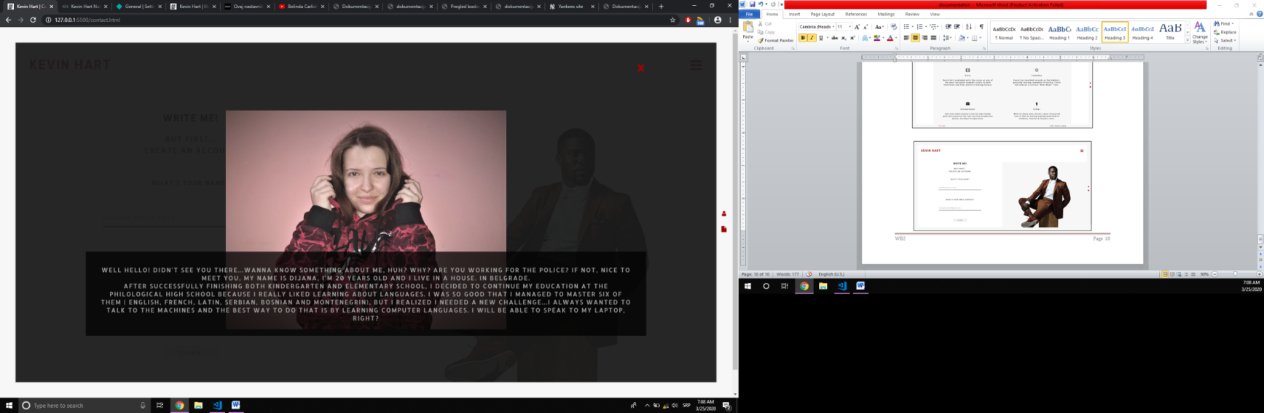Nakon toga,prikazuje mu polje za unos poruke od kojeg očekuje da ispiše minimum 10 reči.

Malo ja->

# Kodovi

## *HTML*

**1)INDEX.HTML-HOME PAGE**

<!DOCTYPE html>

<html lang="en">

<head>

<meta charset="UTF-8">

<meta name="viewport" content="width=device-width, initial-scale=1.0">

<meta http-equiv="X-UA-Compatible" content="ie=edge">

<meta name="description" content="Little man with big heart making some content to make some people feel content" />

<meta name="keywords" content="Kevin,Hart,production,tour,entertainment,comedy" />

<meta name="author" content="Dijana Lazic" />

<link href="https://fonts.googleapis.com/css?family=Alegreya:900" rel="stylesheet">

<link rel="stylesheet" href="https://cdnjs.cloudflare.com/ajax/libs/font-awesome/4.7.0/css/font-awesome.min.css" />

<link rel="shortcut icon" href="assets/images/ajkon.ico" sizes="32x32" />

<link rel="stylesheet" type="text/css" href="assets/css/style.css" />

<title>Kevin Hart | Home page</title>

</head>

<body>

<div id="goreIvica"></div>

<div id="desnoIvica">

<ul>

<li>

<a href="#" id="open-author" title="The author">

<i class="fa fa-user"></i>

</a>

</li>

<li>

<a href="documentation.pdf" target="_blank" title="D(x2)ocumentation">

<i class="fa fa-file"></i>

</a>

</li>

</ul>

</div>

<div id="doleIvica"></div>

<div id="levoIvica"></div>

<nav class="sakriven">

<!-- fiksiran -->

<a href="index.html">

<h1>Kevin Hart</h1>

</a>

<span id="dobrodoslica"></span>

<div id="drustvene-mreze"></div>

<a href="#" class="iksic sakriven nemaGa"><i class="fa fa-times"></i></a>

<div class="linkoviMenija sakriven">

<a href="#"><i class="fa fa-bars"></i></a>

<a href="#" class="iksic sakriven"><i class="fa fa-times"></i></a>

</div>

</nav>

<div id="omotac">

<header id="meni">

<div id="logo">

<a href="index.html" title="Home page">

<h1>Kevin Hart</h1>

</a>

</div>

<div class="linkoviMenija">

<a href="#"><i class="fa fa-bars"></i></a>

<a href="#" class="iksic sakriven"><i class="fa fa-times"></i></a>

</div>

</header>

<div id="slajder">

<a href="#">

<span><i class="fa fa-angle-double-down"></i></span>

<span>Scroll down</span>

</a>

</div>

<div id="sadrzaj">

<div id="uvod">

<img src="assets/images/hartbit.png" alt="Hart Beat" />

<span></span>

<p>

Hartbeat Production is an entertainment company created by comedian Kevin Hart. The company

produces, film, tv, live and digital entertainment for distribution across all digital platforms

including theatrical, television, and emerging digital technologies.

</p>

<span></span>

</div>

<div id="desavanja"></div>

</div>

<div id="crnMeni" class="sakriven">

<h2><a href="index.html">KH</a></h2>

</div>

</div>

<footer class="sakriven">

<a href="#">To top</a>

<span id="izlogovanje"></span>

<p>Copy right</p>

</footer>

<div id="autor" class="sakriven">

<div id="autor-sadrzaj">

<span id="zatvoriAutora">&times;</span>

<p></p>

<img src="assets/images/author.jpg" alt="Its me">

</div>

</div>

<script src="assets/js/jquery-3.3.1.min.js"></script>

<script src="assets/js/main.js"></script>

</body>

</html>

**2)NEWS.HTML-BLOG**

<!DOCTYPE html>

<html lang="en">

<head>

<meta charset="UTF-8">

<meta name="viewport" content="width=device-width, initial-scale=1.0">

<meta http-equiv="X-UA-Compatible" content="ie=edge">

<meta name="description" content="Wandering what Kev's been up to?Keep up with his intriguing life right here..." />

<meta name="keywords" content="Kevin,Hart,news,press,media,read,life" />

<meta name="author" content="Dijana Lazic" />

<link href="https://fonts.googleapis.com/css?family=Alegreya:900" rel="stylesheet">

<link rel="stylesheet" href="https://cdnjs.cloudflare.com/ajax/libs/font-awesome/4.7.0/css/font-awesome.min.css" />

<link rel="shortcut icon" href="assets/images/ajkon.ico" sizes="32x32" />

<link rel="stylesheet" type="text/css" href="assets/css/style.css" />

<title>Kevin Hart | News, press & media</title>

</head>

<body>

<div id="goreIvica"></div>

<div id="desnoIvica">

<ul>

<li>

<a href="#" id="open-author" title="The author">

<i class="fa fa-user"></i>

</a>

</li>

<li>

<a href="documentation.pdf" target="_blank" title="D(x2)ocumentation">

<i class="fa fa-file"></i>

</a>

</li>

</ul>

</div>

<div id="doleIvica"></div>

<div id="levoIvica"></div>

<nav class="sakriven">

<!-- fiksiran -->

<a href="index.html">

<h1>Kevin Hart</h1>

</a>

<span id="dobrodoslica"></span>

<div id="drustvene-mreze"></div>

<a href="#" class="iksic sakriven nemaGa"><i class="fa fa-times"></i></a>

<div class="linkoviMenija sakriven">

<a href="#"><i class="fa fa-bars"></i></a>

<a href="#" class="iksic sakriven"><i class="fa fa-times"></i></a>

</div>

</nav>

<div id="omotac">

<header id="meni">

<div id="logo">

<a href="index.html">

<h1>Kevin Hart</h1>

</a>

</div>

<div class="linkoviMenija">

<a href="#"><i class="fa fa-bars"></i></a>

<a href="#" class="iksic sakriven"><i class="fa fa-times"></i></a>

</div>

</header>

<div id="slajder">

<div id="naslov">

<h2><span>Blog</span> News, press & media</h2>

<span><a href="#">Filter</a></span>

</div>

<a href="#sadrzaj">

<span><i class="fa fa-angle-double-down"></i></span>

<span>Scroll down</span>

</a>

</div>

<div id="sadrzaj">

<div id="pretraga">

<div id="pretrazivanje">

<input type="text" placeholder="Search..." />

</div>

<div id="naslovKat"></div>

<div id="sortiranje"></div>

</div>

<div class="deO3"></div>

</div>

<div id="crnMeni" class="sakriven">

<h2><a href="index.html">KH</a></h2>

</div>

</div>

<footer class="sakriven">

<a href="#">To top</a>

<span id="izlogovanje"></span>

<p>Copy right</p>

</footer>

<div id="listaFiltera" class="sakriven">

<div id="listaFiltera-sadrzaj">

<span id="zatvoriFilter">&times;</span>

</div>

</div>

<div id="autor" class="sakriven">

<div id="autor-sadrzaj">

<span id="zatvoriAutora">&times;</span>

<p></p>

<img src="assets/images/author.jpg" alt="Its me">

</div>

</div>

<script src="assets/js/jquery-3.3.1.min.js"></script>

<script src="assets/js/main.js"></script>

</body>

</html>

**3)ABOUT.HTML-ABOUT**

<!DOCTYPE html>

<html lang="en">

<head>

<meta charset="UTF-8">

<meta name="viewport" content="width=device-width, initial-scale=1.0">

<meta http-equiv="X-UA-Compatible" content="ie=edge">

<meta name="description" content="History, long as its owner's height, explained right here! " />

<meta name="keywords" content="Kevin,Hart,history,comedy,actor,film" />

<meta name="author" content="Dijana Lazic" />

<link href="https://fonts.googleapis.com/css?family=Alegreya:900" rel="stylesheet">

<link rel="stylesheet" href="https://cdnjs.cloudflare.com/ajax/libs/font-awesome/4.7.0/css/font-awesome.min.css" />

<link rel="shortcut icon" href="assets/images/ajkon.ico" sizes="32x32" />

<link rel="stylesheet" type="text/css" href="assets/css/style.css" />

<title>Kevin Hart | About</title>

</head>

<body>

<div id="goreIvica"></div>

<div id="desnoIvica">

<ul>

<li>

<a href="#" id="open-author" title="The author">

<i class="fa fa-user"></i>

</a>

</li>

<li>

<a href="documentation.pdf" target="_blank" title="D(x2)ocumentation">

<i class="fa fa-file"></i>

</a>

</li>

</ul>

</div>

<div id="doleIvica"></div>

<div id="levoIvica"></div>

<nav class="sakriven">

<!-- fiksiran -->

<a href="index.html">

<h1>Kevin Hart</h1>

</a>

<span id="dobrodoslica"></span>

<div id="drustvene-mreze"></div>

<a href="#" class="iksic sakriven nemaGa"><i class="fa fa-times"></i></a>

<div class="linkoviMenija sakriven">

<a href="#"><i class="fa fa-bars"></i></a>

<a href="#" class="iksic sakriven"><i class="fa fa-times"></i></a>

</div>

</nav>

<div id="omotac">

<header id="meni">

<div id="logo">

<a href="index.html">

<h1>Kevin Hart</h1>

</a>

</div>

<div class="linkoviMenija">

<a href="#"><i class="fa fa-bars"></i></a>

<a href="#" class="iksic sakriven"><i class="fa fa-times"></i></a>

</div>

</header>

<div id="slajder">

<div id="naslov">

<h2><span>About</span> I am Kevin Hart</h2>

<p>Comedic rockstar</p>

</div>

<a href="#sadrzaj">

<span><i class="fa fa-angle-double-down"></i></span>

<span>Scroll down</span>

</a>

</div>

<div id="sadrzaj">

<div class="deO">

<div class="fleksuj">

<h3>Who is Kevin Hart?</h3>

<p>

Kevin Hart exploded onto the scene as one of the most versatile comedic actors in both

television and film; and he’s making history.

<br><br>

Hart has appeared in such films as Meet the Fockers sequel aka Little Fockers, and Death at a

Funeral, alongside Chris Rock, Tracy Morgan and Martin Lawrence. He also co-starred alongside

Matthew McConaughey and Kate Hudson in Fool’s Gold, Along Came Polly opposite Ben Stiller and

Jennifer Aniston as well as opposite Steve Carell in The 40 Year Old Virgin. To read Hart’s

Official Biography, click here.

<br><br>

With over half a Million tickets sold in the first weekend, Hart is now smashing ticket sales

records with his <b>What Now? Tour</b>.Don’t miss your opportunity to see the legend in action

on the Silver Screen, October 14, 2016.

</p>

</div>

<div class="fleksuj">

<img src="assets/images/about.jpg" alt="The Kevin Hart" />

</div>

</div>

<div class="deO">

<h3>The plastic cup boyz</h3>

<div class="deO3"></div>

</div>

<div class="deO">

<h3>Many hats</h3>

<div id="centralizovano">

<div class="deO"></div>

</div>

</div>

</div>

<div id="crnMeni" class="sakriven">

<h2><a href="index.html">KH</a></h2>

</div>

</div>

<footer class="sakriven">

<a href="#">To top</a>

<span id="izlogovanje"></span>

<p>Copy right</p>

</footer>

<div id="autor" class="sakriven">

<div id="autor-sadrzaj">

<span id="zatvoriAutora">&times;</span>

<p></p>

<img src="assets/images/author.jpg" alt="Its me">

</div>

</div>

<script src="assets/js/jquery-3.3.1.min.js"></script>

<script src="assets/js/main.js"></script>

</body>

</html>

**4)CONTACT.HTML-CONTACT**

<!DOCTYPE html>

<html lang="en">

<head>

<meta charset="UTF-8">

<meta name="viewport" content="width=device-width, initial-scale=1.0">

<meta http-equiv="X-UA-Compatible" content="ie=edge">

<meta name="description" content="Let the Kevin Hart know who he keeps cracking up! So, go ahead, write him something..." />

<meta name="keywords" content="Kevin,Hart,account,message,fan,write" />

<meta name="author" content="Dijana Lazic" />

<link href="https://fonts.googleapis.com/css?family=Alegreya:900" rel="stylesheet">

<link rel="stylesheet" href="https://cdnjs.cloudflare.com/ajax/libs/font-awesome/4.7.0/css/font-awesome.min.css" />

<link rel="shortcut icon" href="assets/images/ajkon.ico" sizes="32x32" />

<link rel="stylesheet" type="text/css" href="assets/css/style.css" />

<title>Kevin Hart | Contact</title>

</head>

<body>

<div id="goreIvica"></div>

<div id="desnoIvica">

<ul>

<li>

<a href="#" id="open-author" title="The author">

<i class="fa fa-user"></i>

</a>

</li>

<li>

<a href="documentation.pdf" target="_blank" title="D(x2)ocumentation">

<i class="fa fa-file"></i>

</a>

</li>

</ul>

</div>

<div id="doleIvica"></div>

<div id="levoIvica"></div>

<nav class="sakriven">

<!-- fiksiran -->

<a href="index.html">

<h1>Kevin Hart</h1>

</a>

<span id="dobrodoslica"></span>

<div id="drustvene-mreze"></div>

<a href="#" class="iksic sakriven nemaGa"><i class="fa fa-times"></i></a>

<div class="linkoviMenija sakriven">

<a href="#"><i class="fa fa-bars"></i></a>

<a href="#" class="iksic sakriven"><i class="fa fa-times"></i></a>

</div>

</nav>

<div id="omotac">

<header id="meni">

<div id="logo">

<a href="index.html">

<h1>Kevin Hart</h1>

</a>

</div>

<div class="linkoviMenija">

<a href="#"><i class="fa fa-bars"></i></a>

<a href="#" class="iksic sakriven"><i class="fa fa-times"></i></a>

</div>

</header>

<div id="sadrzaj">

<div id="kontaktiranje">

<div class="fleksuj">

<h2>Write me!</h2>

<p>But first...<br />Create an account</p>

<!-- sakriveno dok se ne uloguje -->

<p class="ulogovan sakriven"><i>No matter how busy I am, your emails and messages make my day. But

listen, People. I’m running an empire, so please don’t get mad if I can’t answer every

single message. But I promise, I read your messages. I am your biggest little fan! Now get

to writin’.</i></p>

<form action="#" method="GET" id="forma" name="forma">

<label for="ime">What's your name?</label><br />

<input type="text" name="ime" id="ime" placeholder="Example:Mariah Carey" />

<span></span><br /><br>

<label for="ime">What's your email address?</label><br />

<input type="text" name="mejl" id="mejl" placeholder="Example:mariah@gmail.com" />

<span></span><br>

<input type="button" value="Create" id="nalog" />

</form>

<!-- posle se pokaze -->

<div id="zaPoruku" form="forma" class="sakriven">

<label for="ime">What's on your mind?</label><br />

<textarea name="poruka" id="poruka" cols="30" rows="10"></textarea><br />

<input type="button" value="Send my message" id="posalji" /><br />

<span></span>

</div>

</div>

<div class="fleksuj">

<img src="assets/images/contact.png" alt="El Kevin Hart" />

</div>

</div>

</div>

<div id="crnMeni" class="sakriven">

<h2><a href="index.html">KH</a></h2>

</div>

</div>

<footer class="sakriven">

<a href="#">To top</a>

<span id="izlogovanje"></span>

<p>Copy right</p>

</footer>

<div id="modal" class="sakriven">

<div id="modal-sadrzaj">

<span id="zatvori">&times;</span>

<p></p>

</div>

</div>

<div id="autor" class="sakriven">

<div id="autor-sadrzaj">

<span id="zatvoriAutora">&times;</span>

<p></p>

<img src="assets/images/author.jpg" alt="Its me">

</div>

</div>

<script src="assets/js/jquery-3.3.1.min.js"></script>

<script src="assets/js/main.js"></script>

</body>

</html>

## *CSS*

@import url("https://fonts.googleapis.com/css?family=Allerta&display=swap");

* {

margin: 0px;

padding: 0px;

-webkit-box-sizing: border-box;

box-sizing: border-box;

font-family: 'Allerta';

text-transform: uppercase;

letter-spacing: 2px;

}

* input[type="button"] {

cursor: pointer;

}

* textarea {

resize: vertical;

overflow: auto;

text-transform: initial;

}

* a {

text-decoration: none;

color: #9e0404;

}

* ul {

list-style-type: none;

}

@-webkit-keyframes ulasci {

from {

-webkit-transform: scaleY(0);

transform: scaleY(0);

}

to {

-webkit-transform: scaleY(1);

transform: scaleY(1);

}

}

@keyframes ulasci {

from {

-webkit-transform: scaleY(0);

transform: scaleY(0);

}

to {

-webkit-transform: scaleY(1);

transform: scaleY(1);

}

}

@-webkit-keyframes lentry {

from {

width: 0px;

}

to {

width: 40px;

}

}

@keyframes lentry {

from {

width: 0px;

}

to {

width: 40px;

}

}

@-webkit-keyframes entry {

from {

height: 0px;

}

to {

height: 40px;

}

}

@keyframes entry {

from {

height: 0px;

}

to {

height: 40px;

}

}

@-webkit-keyframes fadein {

from {

opacity: 0;

}

to {

opacity: 1;

}

}

@keyframes fadein {

from {

opacity: 0;

}

to {

opacity: 1;

}

}

#goreIvica {

position: fixed;

background-color: #f7f7f7;

z-index: 5;

height: 40px;

-webkit-animation: entry;

animation: entry;

-webkit-animation-duration: 3s;

animation-duration: 3s;

width: 100%;

top: 0;

}

#desnoIvica {

position: fixed;

background-color: #f7f7f7;

z-index: 5;

width: 40px;

height: 100%;

-webkit-animation: lentry;

animation: lentry;

-webkit-animation-duration: 3s;

animation-duration: 3s;

right: 0;

}

#desnoIvica ul {

text-align: center;

margin-top: 45vh;

font-size: 100%;

}

#desnoIvica ul li {

margin-bottom: 50%;

}

#doleIvica {

position: fixed;

background-color: #f7f7f7;

z-index: 5;

height: 40px;

-webkit-animation: entry;

animation: entry;

-webkit-animation-duration: 3s;

animation-duration: 3s;

width: 100%;

bottom: 0;

}

#levoIvica {

position: fixed;

background-color: #f7f7f7;

z-index: 5;

width: 40px;

-webkit-animation: lentry;

animation: lentry;

-webkit-animation-duration: 3s;

animation-duration: 3s;

height: 100%;

left: 0;

}

#omotac {

margin: 40px;

position: relative;

z-index: 4;

}

#omotac #meni {

position: absolute;

padding: 2%;

text-transform: uppercase;

width: 100%;

top: 0px;

z-index: 3;

height: 100px;

-webkit-animation: fadein;

animation: fadein;

-webkit-animation-duration: 3s;

animation-duration: 3s;

display: -webkit-box;

display: -ms-flexbox;

display: flex;

-ms-flex-wrap: wrap;

flex-wrap: wrap;

-webkit-box-pack: justify;

-ms-flex-pack: justify;

justify-content: space-between;

}

#omotac #meni .linkoviMenija {

font-size: 35px;

}

#omotac #slajder {

position: relative;

min-height: calc(100vh - 80px);

text-align: center;

background-position: center;

background-size: cover;

background-attachment: fixed;

}

#omotac #slajder #naslov {

-webkit-animation: fadein;

animation: fadein;

-webkit-animation-duration: 3s;

animation-duration: 3s;

position: absolute;

color: #fff;

top: 40%;

left: 35%;

text-transform: uppercase;

}

#omotac #slajder #naslov h2 {

font-size: 3.5vw;

margin-bottom: 10%;

}

#omotac #slajder #naslov span:first-child {

position: absolute;

color: rgba(247, 247, 247, 0.3);

font-size: 6vw;

margin-left: 15%;

margin-top: -5%;

}

#omotac #slajder #naslov span:not(:first-child) {

margin-left: -20%;

border-top: 2px solid #9e0404;

}

#omotac #slajder #naslov span:not(:first-child) a {

color: #fff;

}

#omotac #slajder > a {

margin-left: -3%;

position: absolute;

bottom: 2%;

font-size: 1vw;

}

#omotac #slajder > a span:first-child {

display: block;

font-size: 3vw;

}

#omotac #sadrzaj {

text-transform: uppercase;

}

#omotac #sadrzaj h3 {

margin: 20px 0px;

}

#omotac #sadrzaj #uvod {

text-align: center;

padding: 10%;

}

#omotac #sadrzaj #uvod img {

height: 100%;

margin-bottom: 2%;

}

#omotac #sadrzaj #uvod p {

font-size: 1.5vw;

text-transform: uppercase;

}

#omotac #sadrzaj #uvod span {

display: block;

height: 2px;

background-color: #000;

width: 40px;

margin: 20px;

margin-left: 50%;

}

#omotac #sadrzaj #desavanja .desavanje span:first-child {

position: absolute;

color: rgba(158, 4, 4, 0.5);

margin-top: -1%;

font-size: 3vw;

z-index: -5;

}

#omotac #sadrzaj #desavanja .desavanje span:not(:first-child) {

display: block;

height: 2px;

background-color: #000;

width: 40px;

margin: 20px;

margin: 20px;

}

#omotac #sadrzaj #desavanja .desavanje .fleksuj p:last-of-type {

text-transform: initial;

}

#omotac #sadrzaj .desavanje, #omotac #sadrzaj .deO, #omotac #sadrzaj #kontaktiranje {

display: -webkit-box;

display: -ms-flexbox;

display: flex;

-ms-flex-wrap: wrap;

flex-wrap: wrap;

-ms-flex-pack: distribute;

justify-content: space-around;

}

#omotac #sadrzaj .desavanje .fleksuj, #omotac #sadrzaj .deO .fleksuj, #omotac #sadrzaj #kontaktiranje .fleksuj {

width: 50%;

min-height: 400px;

}

#omotac #sadrzaj .desavanje .fleksuj h3, #omotac #sadrzaj .deO .fleksuj h3, #omotac #sadrzaj #kontaktiranje .fleksuj h3 {

margin: 30px;

font-size: 2vw;

}

#omotac #sadrzaj .desavanje .fleksuj p, #omotac #sadrzaj .deO .fleksuj p, #omotac #sadrzaj #kontaktiranje .fleksuj p {

margin: 25px;

font-size: 1vw;

}

#omotac #sadrzaj .desavanje .fleksuj img, #omotac #sadrzaj .deO .fleksuj img, #omotac #sadrzaj #kontaktiranje .fleksuj img {

width: 100%;

}

#omotac #sadrzaj .desavanje .fleksuj .ulogovan, #omotac #sadrzaj .deO .fleksuj .ulogovan, #omotac #sadrzaj #kontaktiranje .fleksuj .ulogovan {

padding: 5%;

}

#omotac #sadrzaj .desavanje:nth-of-type(even) {

-webkit-box-orient: horizontal;

-webkit-box-direction: reverse;

-ms-flex-direction: row-reverse;

flex-direction: row-reverse;

}

#omotac #sadrzaj .deO:first-child {

background-color: #f7f7f7;

padding: 5% 0%;

}

#omotac #sadrzaj .deO:first-child h3 {

text-align: center;

}

#omotac #sadrzaj .deO:first-child .fleksuj img {

width: 50%;

margin-left: 25%;

}

#omotac #sadrzaj .deO:first-child p {

padding: 10%;

text-transform: initial;

}

#omotac #sadrzaj .deO h3 {

margin: 5% 0%;

font-size: 2vw;

}

#omotac #sadrzaj .deO .deO3 .fleksuj {

margin-bottom: 0%;

}

#omotac #sadrzaj .deO .deO3 .fleksuj figure {

height: 350px;

}

#omotac #sadrzaj .desavanje .fleksuj h3 {

margin-top: 10%;

}

#omotac #sadrzaj figure {

overflow: hidden;

position: relative;

}

#omotac #sadrzaj figure img {

-webkit-transition: -webkit-transform 2s ease-in-out;

transition: -webkit-transform 2s ease-in-out;

transition: transform 2s ease-in-out;

transition: transform 2s ease-in-out, -webkit-transform 2s ease-in-out;

}

#omotac #sadrzaj figure:hover img {

-webkit-transform: scale(1.1);

transform: scale(1.1);

}

#omotac #sadrzaj figure > p {

color: #9e0404;

position: absolute;

top: -3%;

right: 3%;

-webkit-transform: rotate(20deg);

transform: rotate(20deg);

}

#omotac #sadrzaj #pretraga {

margin: 50px;

display: -webkit-box;

display: -ms-flexbox;

display: flex;

-ms-flex-wrap: wrap;

flex-wrap: wrap;

-webkit-box-pack: justify;

-ms-flex-pack: justify;

justify-content: space-between;

}

#omotac #sadrzaj #pretraga input[type=text], #omotac #sadrzaj #pretraga select {

margin: 5% 0%;

width: 100%;

text-transform: initial;

height: 50px;

border: 0px;

border-bottom: 2px solid #000;

}

#omotac #sadrzaj #pretraga select option {

color: #9e0404;

}

#omotac #sadrzaj #pretraga #naslovKat {

font-size: 2vw;

}

#omotac #sadrzaj .deO3 {

display: -webkit-box;

display: -ms-flexbox;

display: flex;

-ms-flex-wrap: wrap;

flex-wrap: wrap;

-ms-flex-pack: distribute;

justify-content: space-around;

text-align: center;

}

#omotac #sadrzaj .deO3 img {

width: 100%;

}

#omotac #sadrzaj .deO3 input {

margin: 10px 0px;

padding: 10px 20px;

}

#omotac #sadrzaj .deO3 .fleksuj {

margin-bottom: 5%;

width: 30%;

text-align: left;

}

#omotac #sadrzaj .deO3 .fleksuj figure img {

height: 100%;

}

#omotac #sadrzaj .deO3 .fleksuj p {

margin: 20px 0px;

}

#omotac #sadrzaj .deO3 .fleksuj .info {

margin: 20px;

display: -webkit-box;

display: -ms-flexbox;

display: flex;

-ms-flex-wrap: wrap;

flex-wrap: wrap;

-webkit-box-pack: justify;

-ms-flex-pack: justify;

justify-content: space-between;

}

#omotac #sadrzaj #centralizovano {

text-align: center;

margin: auto 10%;

}

#omotac #sadrzaj #centralizovano .fleksuj {

padding: 5%;

min-height: 250px;

}

#omotac #sadrzaj #centralizovano .fleksuj p {

padding: 0%;

}

#omotac #sadrzaj #centralizovano .fleksuj i {

font-size: 2vw;

}

#omotac #sadrzaj #kontaktiranje {

display: -webkit-box;

display: -ms-flexbox;

display: flex;

-ms-flex-wrap: wrap;

flex-wrap: wrap;

-ms-flex-pack: distribute;

justify-content: space-around;

min-height: 500px;

text-align: center;

line-height: 30px;

padding-top: 10%;

}

#omotac #sadrzaj #kontaktiranje input[type=button] {

margin-top: 5%;

padding: 0% 5%;

text-transform: initial;

height: 30px;

border: 0px;

}

#omotac #sadrzaj #kontaktiranje textarea {

width: 70%;

border: 0px;

border-bottom: 2px solid #000;

}

#omotac #sadrzaj #kontaktiranje #forma {

margin-top: 50px;

line-height: 40px;

}

#omotac #sadrzaj #kontaktiranje #forma input[type=text] {

margin: 5% 0%;

width: 50%;

text-transform: initial;

height: 50px;

border: 0px;

border-bottom: 2px solid #000;

}

#omotac #crnMeni {

background-color: rgba(0, 0, 0, 0.95);

text-align: center;

position: fixed;

top: 40px;

bottom: 40px;

width: 100%;

height: 100%;

opacity: 0.75;

}

#omotac #crnMeni h2 {

margin: 5%;

}

#omotac #crnMeni h2 a {

color: #9e0404;

font-size: 2vmax;

}

#omotac #crnMeni ul {

margin: 15% 10%;

display: -webkit-box;

display: -ms-flexbox;

display: flex;

-ms-flex-wrap: wrap;

flex-wrap: wrap;

-ms-flex-pack: distribute;

justify-content: space-around;

}

#omotac #crnMeni ul li span {

visibility: hidden;

font-size: 4vmax;

position: absolute;

margin: -1.5% 0% 0% 2%;

color: #aaa;

z-index: -5;

}

#omotac #crnMeni ul li:hover span {

visibility: visible;

-webkit-animation: fadein 0.5s;

animation: fadein 0.5s;

}

#omotac #crnMeni ul a {

color: #9e0404;

font-size: 2vmax;

}

#modal, #listaFiltera, #autor {

position: fixed;

z-index: 100;

left: 0;

top: 0;

bottom: 0;

width: 100%;

height: 100%;

overflow: auto;

background-color: black;

background-color: rgba(0, 0, 0, 0.4);

}

#modal #modal-sadrzaj, #modal #listaFiltera-sadrzaj, #modal #autor-sadrzaj, #listaFiltera #modal-sadrzaj, #listaFiltera #listaFiltera-sadrzaj, #listaFiltera #autor-sadrzaj, #autor #modal-sadrzaj, #autor #listaFiltera-sadrzaj, #autor #autor-sadrzaj {

text-align: center;

background-color: rgba(254, 254, 254, 0.1);

border: 1px solid #888;

width: 100%;

height: 100%;

}

#modal #modal-sadrzaj #listaKategorija, #modal #listaFiltera-sadrzaj #listaKategorija, #modal #autor-sadrzaj #listaKategorija, #listaFiltera #modal-sadrzaj #listaKategorija, #listaFiltera #listaFiltera-sadrzaj #listaKategorija, #listaFiltera #autor-sadrzaj #listaKategorija, #autor #modal-sadrzaj #listaKategorija, #autor #listaFiltera-sadrzaj #listaKategorija, #autor #autor-sadrzaj #listaKategorija {

margin-top: 5%;

font-size: 1.5vw;

}

#modal #modal-sadrzaj #listaKategorija li, #modal #listaFiltera-sadrzaj #listaKategorija li, #modal #autor-sadrzaj #listaKategorija li, #listaFiltera #modal-sadrzaj #listaKategorija li, #listaFiltera #listaFiltera-sadrzaj #listaKategorija li, #listaFiltera #autor-sadrzaj #listaKategorija li, #autor #modal-sadrzaj #listaKategorija li, #autor #listaFiltera-sadrzaj #listaKategorija li, #autor #autor-sadrzaj #listaKategorija li {

height: 100%;

padding: 2% 0%;

}

#modal #modal-sadrzaj #listaKategorija li:hover, #modal #listaFiltera-sadrzaj #listaKategorija li:hover, #modal #autor-sadrzaj #listaKategorija li:hover, #listaFiltera #modal-sadrzaj #listaKategorija li:hover, #listaFiltera #listaFiltera-sadrzaj #listaKategorija li:hover, #listaFiltera #autor-sadrzaj #listaKategorija li:hover, #autor #modal-sadrzaj #listaKategorija li:hover, #autor #listaFiltera-sadrzaj #listaKategorija li:hover, #autor #autor-sadrzaj #listaKategorija li:hover {

background-color: rgba(254, 254, 254, 0.5);

}

#modal #modal-sadrzaj p, #modal #listaFiltera-sadrzaj p, #modal #autor-sadrzaj p, #listaFiltera #modal-sadrzaj p, #listaFiltera #listaFiltera-sadrzaj p, #listaFiltera #autor-sadrzaj p, #autor #modal-sadrzaj p, #autor #listaFiltera-sadrzaj p, #autor #autor-sadrzaj p {

margin-top: 20%;

font-size: 45px;

}

#modal #zatvori, #modal #zatvoriFilter, #modal #zatvoriAutora, #listaFiltera #zatvori, #listaFiltera #zatvoriFilter, #listaFiltera #zatvoriAutora, #autor #zatvori, #autor #zatvoriFilter, #autor #zatvoriAutora {

color: #9e0404;

float: right;

font-size: 40px;

font-weight: bold;

margin-right: 10%;

margin-top: 2%;

}

#modal #zatvori:hover, #modal #zatvori:focus, #modal #zatvoriFilter:hover, #modal #zatvoriFilter:focus, #modal #zatvoriAutora:hover, #modal #zatvoriAutora:focus, #listaFiltera #zatvori:hover, #listaFiltera #zatvori:focus, #listaFiltera #zatvoriFilter:hover, #listaFiltera #zatvoriFilter:focus, #listaFiltera #zatvoriAutora:hover, #listaFiltera #zatvoriAutora:focus, #autor #zatvori:hover, #autor #zatvori:focus, #autor #zatvoriFilter:hover, #autor #zatvoriFilter:focus, #autor #zatvoriAutora:hover, #autor #zatvoriAutora:focus {

color: black;

text-decoration: none;

cursor: pointer;

}

#autor {

background-color: rgba(0, 0, 0, 0.95);

top: 40px;

left: 40px;

right: 40px;

bottom: 40px;

width: auto;

height: auto;

}

#autor #autor-sadrzaj p {

font-size: 100% !important;

margin: 30% 10% 0% 10%;

color: #aaa;

background-color: rgba(0, 0, 0, 0.75);

padding: 2%;

}

#autor #autor-sadrzaj img {

width: 40%;

position: absolute;

top: 20%;

left: 30%;

z-index: -2;

}

.fiksiranFuter, .fiksiranMeni {

display: -webkit-box;

display: -ms-flexbox;

display: flex;

-ms-flex-wrap: wrap;

flex-wrap: wrap;

-ms-flex-pack: distribute;

justify-content: space-around;

position: fixed;

background-color: #f7f7f7;

z-index: 5;

-webkit-animation: ulasci;

animation: ulasci;

-webkit-animation-duration: 1s;

animation-duration: 1s;

width: 100%;

height: 40px;

z-index: 7;

}

.fiksiranFuter #drustvene-mreze, .fiksiranMeni #drustvene-mreze {

width: 10%;

padding-top: 5px;

}

.fiksiranFuter #drustvene-mreze ul, .fiksiranMeni #drustvene-mreze ul {

display: -webkit-box;

display: -ms-flexbox;

display: flex;

-ms-flex-wrap: wrap;

flex-wrap: wrap;

-ms-flex-pack: distribute;

justify-content: space-around;

}

.fiksiranMeni {

top: 0;

}

.fiksiranFuter {

bottom: 0;

padding-top: 5px;

}

.sakriven {

display: none;

}

#dobrodoslica {

font-size: 100%;

}

@media (max-width: 1300px) {

#uvod img {

width: 100%;

}

#uvod p {

font-size: 1.5vh !important;

}

#kontaktiranje .fleksuj {

margin-top: 5% !important;

}

#kontaktiranje .ulogovan {

font-size: 1.5vw !important;

}

#autor #autor-sadrzaj img {

width: 50% !important;

left: 25% !important;

}

#autor #autor-sadrzaj p {

margin: 5% !important;

margin-top: 50% !important;

font-size: 90% !important;

}

.desavanje .fleksuj {

min-height: 200px !important;

}

.desavanje .fleksuj img {

margin-top: 5% !important;

}

.desavanje .fleksuj p {

font-size: 1.3vmin !important;

}

#listaKategorija {

margin-top: 15% !important;

}

}

@media (max-width: 800px) {

#centralizovano {

margin: 5% !important;

}

#drustvene-mreze {

width: 20% !important;

}

#listaKategorija {

margin-top: 25% !important;

font-size: 2vh !important;

}

#autor #autor-sadrzaj img {

width: 100% !important;

left: 0% !important;

}

#autor #autor-sadrzaj p {

margin: 0% !important;

margin-top: 100% !important;

font-size: 80% !important;

}

.desavanje .fleksuj, .deO3 .fleksuj, .deO .fleksuj, #kontaktiranje .fleksuj {

width: 100% !important;

min-height: 200px !important;

margin-bottom: 5%;

}

.desavanje .fleksuj figure, .deO3 .fleksuj figure, .deO .fleksuj figure, #kontaktiranje .fleksuj figure {

margin: 0% auto !important;

width: 80% !important;

}

.desavanje .fleksuj .info, .deO3 .fleksuj .info, .deO .fleksuj .info, #kontaktiranje .fleksuj .info {

-ms-flex-pack: distribute !important;

justify-content: space-around !important;

}

.desavanje .fleksuj h3, .deO3 .fleksuj h3, .deO .fleksuj h3, #kontaktiranje .fleksuj h3 {

margin: 2% !important;

}

.desavanje .fleksuj p, .deO3 .fleksuj p, .deO .fleksuj p, #kontaktiranje .fleksuj p {

font-size: 1em !important;

}

.desavanje .fleksuj img, .deO3 .fleksuj img, .deO .fleksuj img, #kontaktiranje .fleksuj img {

min-height: 200px;

}

#kontaktiranje .fleksuj {

margin-top: 15% !important;

}

#kontaktiranje .ulogovan {

font-size: 1.5vh !important;

margin: 10% 0% !important;

}

#desavanja .desavanje span:first-child {

position: absolute;

color: rgba(158, 4, 4, 0.5);

margin-top: -2% !important;

margin-left: 0% !important;

font-size: 2.5vh !important;

z-index: -5;

}

#desavanja .desavanje .fleksuj h3 {

text-align: center !important;

}

.desavanje .fleksuj h3 {

font-size: 2vh !important;

}

.desavanje .fleksuj span {

width: 30% !important;

}

.desavanje .fleksuj p {

font-size: 1.5vh !important;

}

#slajder > a {

font-size: 1vh !important;

}

#slajder > a span:first-child {

font-size: 2vh !important;

}

#crnMeni a {

font-size: 3vh !important;

}

#crnMeni ul li {

display: block !important;

width: 100% !important;

margin: 10% auto;

}

#crnMeni ul li span {

margin: -1.5% 10% !important;

}

.fiksiranMeni h1 {

font-size: 2vh !important;

}

#pretraga #pretrazivanje, #pretraga #naslovKat, #pretraga #sortiranje {

text-align: center;

width: 100%;

margin: 1% auto;

}

#pretraga #pretrazivanje input, #pretraga #pretrazivanje select, #pretraga #naslovKat input, #pretraga #naslovKat select, #pretraga #sortiranje input, #pretraga #sortiranje select {

width: 100%;

}

#pretraga #naslovKat {

-webkit-box-ordinal-group: 2;

-ms-flex-order: 1;

order: 1;

font-size: 2vh !important;

}

#slajder {

background-position: center center !important;

height: 50vh !important;

}

}

@media (max-width: 600px) {

@-webkit-keyframes lentry {

from {

width: 0px;

}

to {

width: 10px;

}

}

@keyframes lentry {

from {

width: 0px;

}

to {

width: 10px;

}

}

@-webkit-keyframes entry {

from {

height: 0px;

}

to {

height: 10px;

}

}

@keyframes entry {

from {

height: 0px;

}

to {

height: 10px;

}

}

#omotac {

margin: 10px;

overflow: hidden;

}

#omotac #uvod p {

font-size: 100% !important;

}

#omotac #uvod span {

width: 10% !important;

}

#omotac #slajder {

min-height: calc(100vh - 20px) !important;

}

#omotac #slajder #naslov {

left: 15% !important;

}

#omotac #slajder #naslov h2 {

font-size: 200% !important;

}

#omotac #slajder #naslov h2 span {

font-size: 150% !important;

}

#omotac #slajder > a {

margin-left: -15% !important;

font-size: 100% !important;

}

#omotac #slajder > a i {

font-size: 150% !important;

}

#omotac #desavanja .desavanje .fleksuj h3 {

font-size: 150% !important;

}

#omotac #desavanja .desavanje .fleksuj h3 span {

margin-top: -5% !important;

margin-left: 5% !important;

font-size: 200% !important;

}

#omotac #desavanja .desavanje .fleksuj p {

font-size: 100% !important;

}

#omotac #desavanja .desavanje .fleksuj figure {

width: 100% !important;

}

#modal-sadrzaj p {

margin-top: 50% !important;

}

.nemaGa {

display: none !important;

}

.linkoviMenija {

display: block;

font-size: 150% !important;

}

#logo {

font-size: 80% !important;

}

#dobrodoslica {

display: none;

}

.fiksiranFuter {

display: none;

}

.fiksiranMeni {

-webkit-box-pack: justify;

-ms-flex-pack: justify;

justify-content: space-between;

padding: 0% 5%;

}

.fiksiranMeni h1 {

font-size: 150% !important;

margin-top: 2% !important;

}

.deO h3 {

font-size: 150% !important;

margin: 30% 0% !important;

}

.deO .deO3 .fleksuj {

text-align: center !important;

}

.deO i {

font-size: 150% !important;

}

#goreIvica, #doleIvica {

height: 10px;

}

#listaKategorija {

font-size: 150% !important;

}

#crnMeni {

top: 0px !important;

padding-top: 40px !important;

}

#crnMeni ul li span {

margin-left: 7% !important;

}

#desnoIvica, #levoIvica {

width: 10px;

}

#desnoIvica ul, #levoIvica ul {

display: none;

}

.fiksiranMeni, .fiksiranFuter {

text-align: center;

}

#drustvene-mreze, #izlogovanje + p {

display: none;

}

#pretraga + div .fleksuj {

text-align: center !important;

}

#forma {

line-height: 60px !important;

}

input[type="text"] {

width: 100% !important;

}

}

/*# sourceMappingURL=style.css.map */

## *JS*

window.onload = function () {

//copyrighted:

var godinaUtoku = new Date().getFullYear();

document.querySelector("#izlogovanje").nextElementSibling.innerHTML += "-" + godinaUtoku;

//skrolovanje

$(window).scroll(function () {

var skrol = $(this).scrollTop();

// console.log(skrol)

if (skrol > 300) {

ispisDrustvenihMreza();

$("#omotac").prev().removeClass("sakriven");

$("#omotac").prev().addClass("fiksiranMeni");

$("#omotac").next().removeClass("sakriven");

$("#omotac").next().addClass("fiksiranFuter");

}

else {

$("#omotac").prev().removeClass("fiksiranMeni");

$("#omotac").prev().addClass("sakriven")

$("#omotac").next().removeClass("fiksiranFuter");

$("#omotac").next().addClass("sakriven")

}

$("footer > a:first").on('click', function (e) {

e.preventDefault();

$('html').animate({

scrollTop: 0

}, 500);

});

});

$("#slajder > a:first").click(function (e) {

e.preventDefault();

$('html').animate({

scrollTop: $("#sadrzaj").offset().top

}, 500);

});

//autor model...khm khm...modal

$("#open-author").click(function (e) {

e.preventDefault();

$("#autor").fadeIn("slow");

$("#zatvoriAutora").click(function () {

$("#autor").fadeOut("slow");

})

})

//meni

$(".linkoviMenija").find("a:first").click(function (e) {

e.preventDefault();

$(".iksic").removeClass("sakriven");

$(".fa-bars").parent().hide();

$(".iksic").click(function (e) {

e.preventDefault();

$("#crnMeni").slideUp("slow");

$(".iksic").addClass("sakriven");

$("#logo").css('visibility', 'visible');

$(".linkoviMenija").find("a:first").show();

$(".linkoviMenija").find("a:first").next().addClass("sakriven");

$(".fa-bars").parent().show();

})

$("#logo").css('visibility', 'hidden');

$("#crnMeni").slideDown("slow");

})

//filter lista

$("#naslov span a").click(function (e) {

e.preventDefault();

$("#listaFiltera").slideDown("slow");

$("#zatvoriFilter").click(function () {

$("#listaFiltera").slideUp("slow");

})

})

//za pojedinacne

var url = window.location.pathname;

console.log(url)

if (url.includes("index.html") || url == "/") {

$("#slajder").css(

'background-image', 'url(assets/images/skopi.jpg)'

)

dohvatiDogadjaje();

}

if (url.includes("news.html")) {

$("#slajder").css(

'background-image', 'url(assets/images/slajder68.jpg)'

)

dohvatiVesti();

ispisSortiranja();

$("#pretrazivanje input").keyup(pretrazi)

}

if (url.includes("about.html")) {

$("#slajder").css(

'background-image', 'url(assets/images/slajder701.jpg)'

)

dohvatiMomke();

dohvatiUloge();

}

if (url.includes("contact.html")) {

$("#nalog").click(proveriFormu);

$("#posalji").click(proveriPoruku);

}

}

//sporedni ispisi

function ispisDrustvenihMreza() {

let ispis = "<ul>";

let linkovi = ["facebook", "youtube", "instagram", "twitter"];

for (let i of linkovi) {

ispis += `<li><a href="https://${i}.com"><i class="fa fa-${i}"></i></a></li>`;

}

ispis += "</ul>";

document.getElementById("drustvene-mreze").innerHTML = ispis;

}

function ispisSortiranja() {

let ispis = "<select id='ddlSort'><option value='0'>Sort...</option>";

let niz = ["Newest", "Oldest", "Most viewed"];

for (let i of niz) {

ispis += `

<option value='${i.substr(0, 3)}'>${i}</option>

`;

}

ispis += "</select>";

document.getElementById("sortiranje").innerHTML = ispis;

document.querySelector("#ddlSort").addEventListener("change", sortiraj)

};

function listaKategorija(n) {

let ispis = "<ul id='listaKategorija'>";

ispis += "<li><a href='#' data-idkat='0'>All</a></li>"

let sveKategorije = ["All"];

n.forEach(el => {

for (let c of el.category) {

if (sveKategorije.length > 0) {

if (sveKategorije.indexOf(c.title) == -1) {

sveKategorije.push(c.title)

ispis += `<li><a href='#' data-idkat='${c.id}'></a></li>`;

}

}

else {

sveKategorije.push(c.title)

}

}

})

ispis += "</ul>";

console.log(sveKategorije)

document.querySelector("#listaFiltera-sadrzaj").innerHTML += ispis;

for (let svk in sveKategorije) {

let atags = document.querySelector("#listaKategorija").childNodes[svk].childNodes[0];

atags.innerHTML = sveKategorije[svk];

atags.addEventListener("click", filtriraj)

}

}

function formatirajDatum(d) {

let month = new Date(d).toLocaleString('default', { month: 'short' });

let day = new Date(d).getDate();

let year = new Date(d).getFullYear();

return month + " " + day + "," + year;

}

(function ispisMenija() {

let ispis = "<ul>";

let linkovi = ["news.html", "about.html", "contact.html"];

let nazivi = ["Blog", "About", "Contact"];

for (let i in linkovi) {

ispis += `<li>

<span>${nazivi[i].substr(0, 1)}</span>

<a href="${linkovi[i]}">${nazivi[i]}</a></li>`;

}

ispis += "</ul>";

document.getElementById("crnMeni").innerHTML += ispis;

})();

(function ispisOautoru() {

document.querySelector("#autor-sadrzaj > p").innerHTML = `

Well hello! Didn't see you there...Wanna know something about me, huh? Why? Are you working for the police? If not, nice to meet you, my name is Dijana, I'm 20 years old and I live in a house. In Belgrade.

<br>

After successfully finishing both kindergarten and elementary school, I decided to continue my education

at the Philological High School because I really liked learning about languages. I was so good that I

managed to master six of them ( English, French, Latin, Serbian, Bosnian and Montenegrin), but I

realized I needed a new challenge...I always wanted to talk to the machines and the best way to do that

is by learning computer languages. I will be able to speak to my laptop, right?

`;

})();

//AJAX ft JSON

//---events

function dohvatiDogadjaje() {

$.ajax({

url: "assets/data/events.json",

method: "get",

dataType: "json",

success: function (events) {

ispisiDogadjaje(events);

}

});

}

function ispisiDogadjaje(events) {

let ispis = "";

events.forEach(element => {

ispis += ispisiDogadjaj(element);

});

document.getElementById("desavanja").innerHTML = ispis;

}

function ispisiDogadjaj(element) {

return `<div class="desavanje">

<div class="fleksuj">

<h3><span>${element.godina}</span>${element.naslov}</h3>

<p>${element.kategorija}</p>

<span></span>

<p>${element.tekst}</p>

</div>

<div class="fleksuj">

<img src="${element.slika.src}"

alt="${element.slika.alt}"/>

</div>

</div>`;

}

//---news

function ajaxNews(vraceno) {

$.ajax({

url: "assets/data/news.json",

method: "get",

dataType: "json",

success: vraceno

});

}

function dohvatiVesti() {

ajaxNews(

function (news) {

ispisiVesti(news);

listaKategorija(news)

}

);

}

function ispisiVesti(news) {

let ispis = "";

news.forEach(element => {

ispis += ispisiVest(element);

});

document.getElementsByClassName("deO3")[0].innerHTML = ispis;

}

function ispisiVest(element) {

return `

<div class="fleksuj">

<figure>

<img src="assets/images/${element.slika.src}" alt="${element.slika.alt}"/>

</figure>

<div class="info">

<p>${formatirajDatum(element.datum)}</p>

<p><i class="fa fa-eye"></i>${element.pregledi}</p>

</div>

<h3>${element.naslov} - ${element.magazin}</h3>

<a href='#'>Read More</a>

</div>

`;

}

//---boyz

function dohvatiMomke() {

$.ajax({

url: "assets/data/boys.json",

method: "get",

dataType: "json",

success: function (boys) {

ispisiMomke(boys);

}

});

}

function ispisiMomke(boys) {

let ispis = "";

boys.forEach(element => {

ispis += `<div class="fleksuj">

<figure>

<p>${element.name}</p>

<img src="assets/images/${element.slika.src}" alt="${element.slika.alt}" />

</figure>

<p>${element.role}</p>

<p>"${element.description}"</p>

</div>`;

});

document.getElementsByClassName("deO3")[0].innerHTML += ispis;

}

//---roles

function dohvatiUloge() {

$.ajax({

url: "assets/data/roles.json",

method: "get",

dataType: "json",

success: function (roles) {

ispisiUloge(roles);

}

});

};

function ispisiUloge(roles) {

let ispis = "";

roles.forEach(element => {

ispis += `<div class="fleksuj">

<i class="fa fa-${element.icon}"></i>

<p>${element.name}</p>

<p>${element.desc}</p>

</div>`;

});

$(".deO:last").html(ispis);

}

//provera forme

function proveriFormu() {

let validno = true;

const ime = $("#ime").val().trim();

const mejl = $("#mejl").val().trim();

const reIme = /^[A-Z][a-z]+(\s[A-Z][a-z]+)*$/;

const remejl = /^[A-z0-9\.\_\%\+\-]+@[A-z0-9\.\-]+(\.[A-z]{2,})+$/;

if (ime == "") {

validno = false;

$("#ime").css("border-bottom", "2px solid red");

}

else if (!reIme.test(ime)) {

validno = false;

$("#ime").css("border-bottom", "2px solid red");

$("#ime").next().html("<br><i>Gotta start with an uppercase!</i>");

}

else {

$("#ime").css("border-bottom", "2px solid green");

$("#ime").next().html("");

}

if (mejl == "") {

validno = false;

$("#mejl").css("border-bottom", "2px solid red");

}

else if (!remejl.test(mejl)) {

validno = false;

$("#mejl").css("border-bottom", "2px solid red");

$("#mejl").next().html("<br><i>Don't forget @!</i>");

}

else {

$("#mejl").css("border-bottom", "2px solid green");

$("#mejl").next().html("");

}

if (validno) {

localStorage.setItem("name", ime);

$("#modal").fadeIn("slow");

$("#modal-sadrzaj p").html('Welcome ' + localStorage.getItem("name") + "!");

$("#zatvori").click(function () {

$("#modal").fadeOut("slow");

location.reload();

})

}

}

function proveriPoruku() {

let validno = true;

const poruka = $("#poruka").val().trim();

const rePoruka = /^[\w\d]+(\s+[\w\d]+){9,}$/;

if (poruka == "") {

validno = false;

$("#poruka").css("border-bottom", "2px solid red")

$("#zaPoruku span").html("You have to fill in!");

}

else if (!rePoruka.test(poruka)) {

validno = false;

$("#poruka").css("border-bottom", "2px solid red");

$("#zaPoruku span").html("Minimum 10 words");

}

else {

$("#poruka").css("border-bottom", "2px solid green");

}

if (validno) {

$("#zaPoruku span").html("Successfully sent!");

$("#poruka").val("");

}

}

//local storage ft login/out

(function proveraStorage() {

if (localStorage.getItem("name")) {

//ispisi poruku dobrodoslice

$("#dobrodoslica").html("Wazzup " + localStorage.getItem("name") + "?!");

let log = document.createElement("a");

log.setAttribute("href", "#");

log.innerHTML = "Log out";

document.getElementById("izlogovanje").appendChild(log);

//kontakt stranica se menja

$(".ulogovan").removeClass("sakriven");

$(".ulogovan").prev().hide();

$(".ulogovan").next().hide();

$("#zaPoruku").removeClass("sakriven");

//meni sirenje

$("#crnMeni ul").append("<li id='lgo'><span>L</span><a href='#'>Logout</a></li>")

}

$("#izlogovanje a,#lgo").click(function (e) {

e.preventDefault();

localStorage.removeItem("name");

location.reload();

//kontakt stranica

$(".ulogovan").addClass("sakriven");

$(".ulogovan").prev().show();

$(".ulogovan").next().show();

$("#zaPoruku").addClass("sakriven");

})

})();

//pretraga

function pretrazi() {

let uneto = this.value;

console.log(uneto)

ajaxNews((news) => {

let rezultatPretrage = news.filter(n => {

if (n.naslov.toLowerCase().indexOf(uneto.toLowerCase()) !== -1) {

return true;

}

})

if (rezultatPretrage.length > 0) {

$("#naslovKat").html("")

ispisiVesti(rezultatPretrage)

}

else {

$("#naslovKat").html("No matching results")

$("#pretraga").next().html("")

}

}

);

}

var filtriraneVesti = [];

function sortiraj() {

let izabrano = this.value.toLowerCase();

console.log(izabrano)

ajaxNews((news) => {

if (filtriraneVesti.length > 0) {

filtriraneVesti.sort((a, b) => {

if (izabrano == "new") {

if (a.datum == b.datum) return 0;

return a.datum > b.datum ? -1 : 1;

}

else if (izabrano == "old") {

if (a.datum == b.datum) return 0;

return a.datum > b.datum ? 1 : -1;

}

else if (izabrano == "mos") {

if (a.pregledi == b.pregledi) return 0;

return a.pregledi > b.pregledi ? -1 : 1;

}

});

ispisiVesti(filtriraneVesti);

}

else {

let sortirani = news.sort((a, b) => {

if (izabrano == "new") {

if (a.datum == b.datum) return 0;

return a.datum > b.datum ? -1 : 1;

}

else if (izabrano == "old") {

if (a.datum == b.datum) return 0;

return a.datum > b.datum ? 1 : -1;

}

else if (izabrano == "mos") {

if (a.pregledi == b.pregledi) return 0;

return a.pregledi > b.pregledi ? -1 : 1;

}

});

ispisiVesti(sortirani);

}

}

);

}

function filtriraj() {

let izabrano = $(this).data("idkat")

console.log(izabrano)

ajaxNews((news) => {

filtriraneVesti = news.filter(n => {

if (izabrano == 0) {

$("#naslovKat").html("")

return true;

}

for (let c of n.category) {

if (c.id == izabrano) {

$("#naslovKat").html(c.title)

return true;

}

}

})

console.log(filtriraneVesti)

ispisiVesti(filtriraneVesti)

}

);

}

## *JSON*

**1)EVENTS.JSON**

[

{

"id": 1,

"godina": "2016",

"naslov": "What now",

"kategorija": "Theatrical stand up",

"tekst": "Kevin Hart’s What Now? tour, has become the highest grossing comedy tour ever reported to Billboard Boxscore, selling more than 600,000 tickets and grossing $35 million in less than one month.",

"slika": {

"alt": "Kevin H.",

"src": "assets/images/event1.jpg"

}

},

{

"id": 2,

"godina": "2015",

"naslov": "Kevin Hart presents: Lil Rel",

"kategorija": "TV stand up",

"tekst": "The comedy special, dubbed “Relevant,” will consist of material from two shows. It is presented by star comedian Kevin Hart; “Relevant” is expected to be the third “Kevin Hart presents” special to air on Comedy Central. (Source: Chicago Tribune)",

"slika": {

"alt": "Kevin H.",

"src": "assets/images/event2.jpg"

}

},

{

"id": 3,

"godina": "2015",

"naslov": "Kevin Hart presents: Plastic cup boyz",

"kategorija": "TV stand up",

"tekst": "Kevin Hart’s What Now? tour, has become the highest grossing comedy tour ever reported to Billboard Boxscore, selling more than 600,000 tickets and grossing $35 million in less than one month.",

"slika": {

"alt": "Kevin H.",

"src": "assets/images/event3.jpg"

}

},

{

"id": 4,

"godina": "2013",

"naslov": "Kevin Hart presents: Keith Robinson",

"kategorija": "TV stand up",

"tekst": "Kevin Hart’s What Now? tour, has become the highest grossing comedy tour ever reported to Billboard Boxscore, selling more than 600,000 tickets and grossing $35 million in less than one month.",

"slika": {

"alt": "Kevin H.",

"src": "assets/images/event4.jpg"

}

},

{

"id": 5,

"godina": "2012",

"naslov": "Real husbands of Hollywood",

"kategorija": "TV show",

"tekst": "Kevin Hart’s What Now? tour, has become the highest grossing comedy tour ever reported to Billboard Boxscore, selling more than 600,000 tickets and grossing $35 million in less than one month.",

"slika": {

"alt": "Kevin H.",

"src": "assets/images/event5.jpg"

}

},

{

"id": 6,

"godina": "2011",

"naslov": "Let me explain",

"kategorija": "Theatrical stand up",

"tekst": "Kevin Hart’s What Now? tour, has become the highest grossing comedy tour ever reported to Billboard Boxscore, selling more than 600,000 tickets and grossing $35 million in less than one month.",

"slika": {

"alt": "Kevin H.",

"src": "assets/images/event6.jpg"

}

}

]

**3)CATEGORIES.JSON**

[

{

"id":1,

"name":"Behind the scenes"

},

{

"id":2,

"name":"Photography"

},

{

"id":3,

"name":"Sports"

},

{

"id":4,

"name":"Cover"

},

{

"id":5,

"name":"Editorial"

},

{

"id":6,

"name":"Fashion"

},

{

"id":7,

"name":"Health"

},

{

"id":8,

"name":"Interview"

},

{

"id":9,

"name":"Motion"

},

{

"id":10,

"name":"News"

}

]

**3)NEWS.JSON**

[

{

"id": 1,

"slika": {

"src": "news1.jpg",

"alt": "K.Hart"

},

"category":[

{

"id": 8,

"title": "Interview"

}

],

"datum": "2020-02-15",

"naslov": "Kevin Hart Walk of Fame Honor",

"magazin": "Variety",

"pregledi": 47

},

{

"id": 2,

"slika": {

"src": "news11.jpg",

"alt": "K.Hart"

},

"category": [

{

"id": 8,

"title": "Interview"

}

],

"datum": "2020-01-17",

"naslov": "Inside Hollywood",

"magazin": "Life & Style",

"pregledi": 23

},

{

"id": 3,

"slika": {

"src": "news3.jpg",

"alt": "K.Hart"

},

"category":[

{

"id": 4,

"title": "Cover"

},

{

"id": 6,

"title": "Fashion"

}

],

"datum": "2019-10-03",

"naslov": "Kevin Hart On Moguldom, Marriage & Race In America",

"magazin": "Ebony",

"pregledi": 68

},

{

"id": 4,

"slika": {

"src": "news8.jpg",

"alt": "K.Hart"

},

"category": [

{

"id": 10,

"title": "News"

}

],

"datum": "2020-01-17",

"naslov": "It’s Mecca for Animation",

"magazin": "The Hollywood Reporter",

"pregledi": 53

},

{

"id": 5,

"slika": {

"src": "news5.jpg",

"alt": "K.Hart"

},

"category":[

{

"id": 4,

"title": "Cover"

},

{

"id": 3,

"title": "Sports"

},

{

"id": 7,

"title": "Health"

}

],

"datum": "2020-02-05",

"naslov": "Men’s Fitness Cover",

"magazin": "Men's Fitness",

"pregledi": 14

},

{

"id": 6,

"slika": {

"src": "news6.jpg",

"alt": "K.Hart"

},

"category":[

{

"id": 4,

"title": "Cover"

},

{

"id": 3,

"title": "Sports"

},

{

"id": 7,

"title": "Health"

}

],

"datum": "2019-12-22",

"naslov": "Centrall Intelligence Premier",

"magazin": "Variety",

"pregledi": 7

},

{

"id": 7,

"slika": {

"src": "news9.jpg",

"alt": "K.Hart"

},

"category":[

{

"id": 10,

"title": "News"

},

{

"id": 8,

"title": "Interview"

},

{

"id": 1,

"title": "Behind the scenes"

}

],

"datum": "2020-02-07",

"naslov": "Central Intelligence",

"magazin": "National Enquirer",

"pregledi": 16

},

{

"id": 8,

"slika": {

"src": "news4.jpg",

"alt": "K.Hart"

},

"category": [

{

"id": 10,

"title": "News"

}

],

"datum": "2019-10-05",

"naslov": "The Highest-Paid Comedians 2016: Kevin Hart Dethrones Jerry Seinfeld As Cash King Of Comedy With $87.5 Million Payday",

"magazin": "Forbes",

"pregledi": 53

},

{

"id": 9,

"slika": {

"src": "news2.jpg",

"alt": "K.Hart"

},

"category": [

{

"id": 10,

"title": "News"

}

],

"datum": "2019-12-15",

"naslov": "Kevin Gets His Star On the Hollywood Walk of Fame",

"magazin": "Fame",

"pregledi": 12

},

{

"id": 10,

"slika": {

"src": "news10.jpg",

"alt": "K.Hart"

},

"category":[

{

"id": 3,

"title": "Sports"

},

{

"id": 8,

"title": "Interview"

}

],

"datum": "2019-08-17",

"naslov": "Hot Guys of Summer",

"magazin": "Us Weekly",

"pregledi": 57

},

{

"id": 11,

"slika": {

"src": "news7.jpg",

"alt": "K.Hart"

},

"category": [

{

"id": 8,

"title": "Interview"

}

],

"datum": "2020-02-10",

"naslov": "Movie Previews – Central Intelligence",

"magazin": "Ok!Entertainment",

"pregledi": 10

},

{

"id": 12,

"slika": {

"src": "news12.jpg",

"alt": "K.Hart"

},

"category": [

{

"id": 8,

"title": "Interview"

}

],

"datum": "2020-01-07",

"naslov": "Summer Movie Preview Q&A – Central Intelligence",

"magazin": " New York Times",

"pregledi": 32

}

]

**4)BOYS.JSON**

[

{

"id": 1,

"name": "Spank",

"role": "Dancer",

"description": "Don’t believe the hype about them. I’m really funny.",

"slika":{

"src":"boy1.jpg",

"alt":"Spank guy"

}

},

{

"id": 2,

"name": "Joey",

"role": "Writer",

"description": "Father/Comedian/Writer/Actor…uh, that would just about sum it up!",

"slika":{

"src":"boy2.jpg",

"alt":"Joey guy"

}

},

{

"id": 3,

"name": "Na'im",

"role": "Bff",

"description": "Na’im the Star. Comedian/Actor. Y’all got next; I got now. I’m the one.",

"slika":{

"src":"boy3.jpg",

"alt":"BFF guy"

}

}

]

**5)ROLES.JSON**

[

{

"id":1,

"icon":"film",

"name":"Actor",

"desc":"Kevin Hart exploded onto the scene as one of the most versatile comedic actors in both television and film; and he’s making history."

},

{

"id":2,

"icon":"smile-o",

"name":"Comedian",

"desc":"Kevin has smashed records as the highest-grossing touring comedian in history. Catch him now on is current ‘What Now?’ Tour."

},

{

"id":3,

"icon":"briefcase",

"name":"Entrepreneur",

"desc":"Hart has taken matters into his own hands with the launch of his full-service production house, HartBeat Productions."

},

{

"id":4,

"icon":"child",

"name":"Father",

"desc":"With so many hats, Kevin’s most treasured role is that of loving and devoted Dad to children, Heaven & Hendrix Hart."

}

]